**Research and Publications:**

The field of dentistry is constantly evolving, with new research and publications emerging regularly from all corners of the globe. Here's a glimpse into some of the latest advancements:

**1. Oral microbiome and its link to systemic health:**

**Periodontitis and gut health:**

Research suggest a strong link between gum disease (periodontitis) and gut health. Studies have shown that the inflammatory bacteria in the mouth can travel to the gut and exacerbate existing conditions like colitis and even influence anxiety-like behavior. This highlights the importance of oral hygiene for overall well-being.

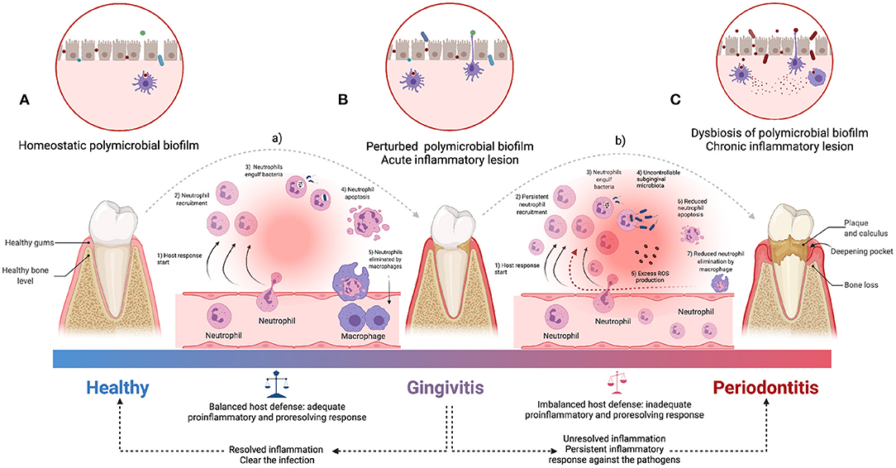

**Teeth as antibody reservoirs:**

A fascinating study revealed that teeth can preserve antibodies for hundreds of years. This opens up exciting possibilities for using dental pulp tissue as a source of historical information about past infections and immune responses.

External Links:

<https://www.nature.com/articles/s41522-023-00462-9>

Periodontitis salivary microbiota exacerbates colitis-induced anxiety-like behavior via gut microbiota

<https://www.sciencedaily.com/releases/2023/08/230816114136.htm>

Teeth Could Preserve Antibodies Hundreds of Years Old, Study Finds

**2. Regenerative dentistry and tissue engineering:**

**Stem cell therapy for dental pulp regeneration:**

Researchers are exploring the use of stem cells to regenerate damaged dental pulp, the soft tissue inside the tooth. This could potentially eliminate the need for root canals and preserve natural teeth.

**3D printing for dental implants and prosthetics:**

3D printing technology is revolutionizing the way dental implants and prosthetics are created. It allows for custom-designed solutions that are more precise and biocompatible, leading to better patient outcomes.

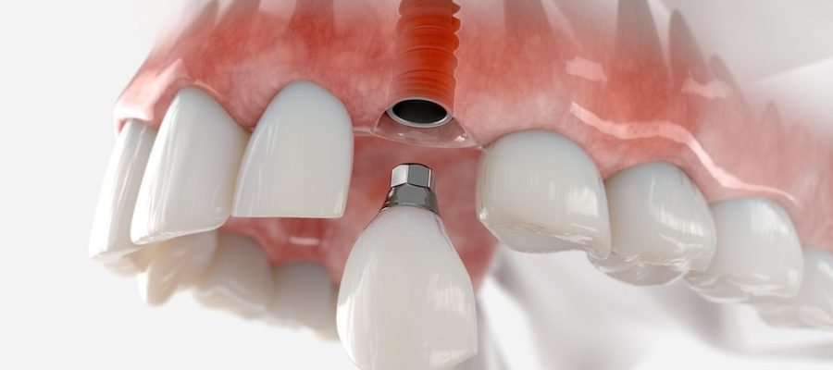

**External Links:**

Dental Pulp Stem Cells: A Review of Their Properties and Potential Applications in Regenerative Dentistry

<https://pubmed.ncbi.nlm.nih.gov/21677085/>

3D Printing for Dental Implants and Prostheses: A Review of the Latest Developments: <https://pubmed.ncbi.nlm.nih.gov/37929684/>

**3. Precision dentistry and personalized medicine:**

**Genetic testing for oral cancer risk:**

Genetic testing is becoming increasingly used to identify individuals at high risk for developing oral cancer. This allows for early intervention and personalized treatment plans.

**AI-powered diagnostics and treatment planning:**

Artificial intelligence (AI) is being used to develop new diagnostic tools and treatment planning software. AI can analyze dental images and data to identify potential problems and recommend the most effective treatment options.

External Link:

Genetic Testing for Oral Cancer Risk:

<https://www.cancer.gov/types/head-and-neck/hp/oral-screening-pdq>

AI-Powered Diagnostics and Treatment Planning in Dentistry: <https://www.ncbi.nlm.nih.gov/pmc/articles/PMC9418762/>

**4. Pain management and minimally invasive procedures:**

**New pain management strategies:**

Researchers are developing new pain management strategies that are less invasive and have fewer side effects than traditional methods. These include nerve blocks, lasers, and non-opioid medications.

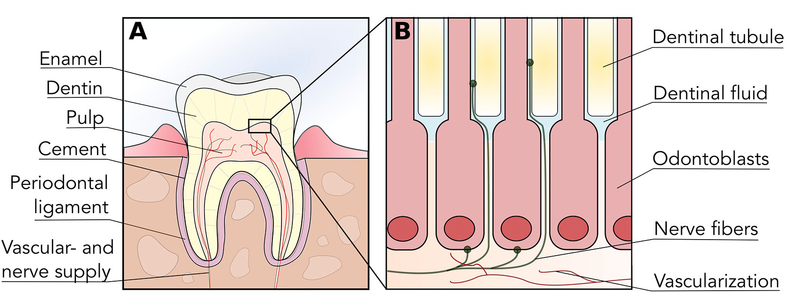

**Minimally invasive dentistry:**

Minimally invasive dentistry techniques aim to preserve as much healthy tooth structure as possible. This includes procedures like minimally invasive fillings, laser caries removal, and microscopic endodontics.

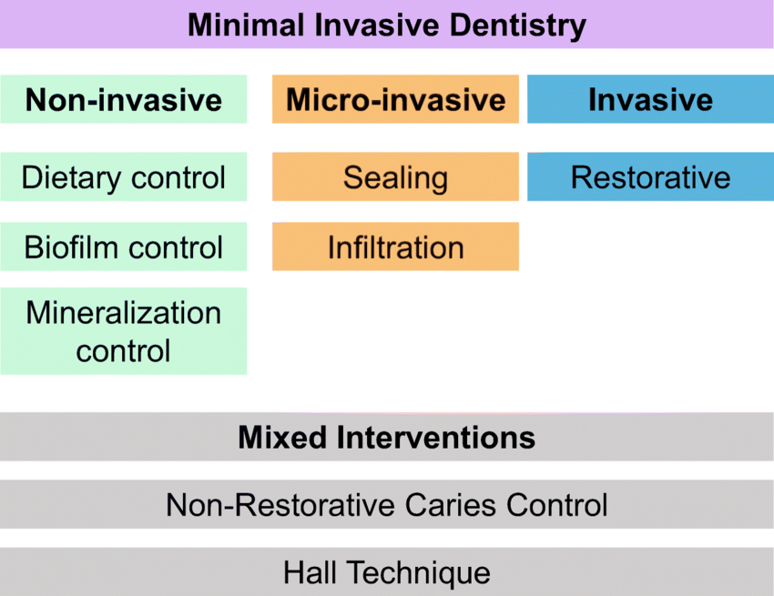

**External Links:**

Journal of the American Dental Association (JADA) article on pain management: <https://jada.ada.org/article/S0002-8177%2819%2930617-8/fulltext>

Minimally Invasive Dentistry: A Review of Techniques and Benefits: <https://www.ncbi.nlm.nih.gov/pmc/articles/PMC4149165/>

**5. Dental materials and technologies:**

**Biodegradable and sustainable materials:**

There is a growing focus on developing biodegradable and sustainable materials for dental applications. This is driven by the need for environmentally friendly solutions and reducing waste.



**Smart materials and sensors:**

Smart materials that can respond to changes in the oral environment are being developed for various applications, such as drug delivery and monitoring oral health.

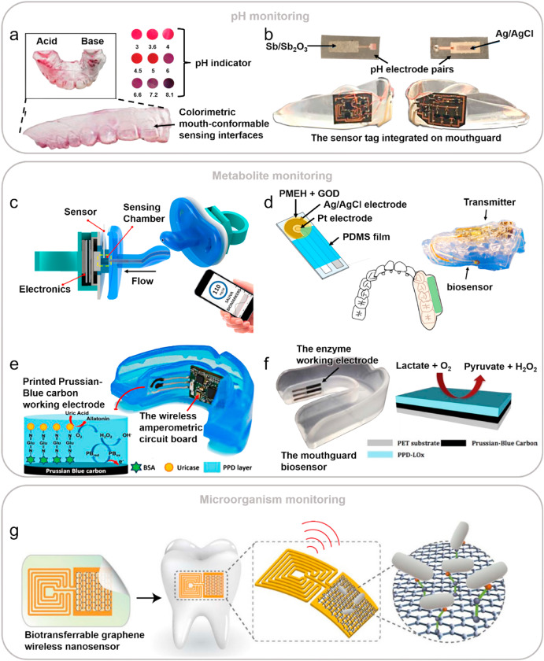

Staying informed about the latest research and publications in dentistry is crucial for dental professionals to provide the best possible care for their patients. By keeping up with the latest advancements, dentists can offer their patients cutting-edge treatments and technologies that can improve their oral health and overall well-being.

External Links:

Biodegradable and Sustainable Materials in Dentistry: <https://www.sciencedirect.com/science/article/abs/pii/B9780128204849000039>

Smart Materials and Sensors for Oral Health Monitoring and Drug Delivery: <https://pubmed.ncbi.nlm.nih.gov/21564111/>

Here are some resources for staying up-to-date on the latest dental research:

**Journal of Dental Research:**

<https://journals.sagepub.com/home/jdr>

The leading journal in dentistry, publishing peer-reviewed research on all aspects of oral health.

**ScienceDaily:**

<https://www.sciencedaily.com/>

A website that aggregates news articles from scientific journals, including those related to dentistry.

**American Dental Association:**

<https://www.ada.org/>

The professional organization for dentists in the United States, providing resources and information on the latest dental research.

**International Journal of Oral Science:**

<https://www.jstage.jst.go.jp/browse/josnusd/>

A peer-reviewed journal publishing research on oral and maxillofacial sciences.

**BONUS RESEARCHES:**

Featured Research:

Highlight groundbreaking research in dental education, summarizing key findings and their implications for teaching and learning.

External Link: <https://www.nature.com/subjects/dentistry>

Publication Opportunities:

Provide information on opportunities for faculty members to contribute to dental education literature through article submissions, book chapters, and conference presentations.

Example Link: <https://opendentistryjournal.com/>